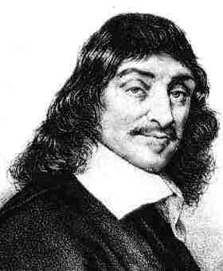**PPE Revision – Scepticism**

What is scepticism and why is Descartes using it?

Scepticism means doubt – Descartes is doubting everything he knows.

Descartes is using scepticism because he wants to be totally sure about what he knows. Any knowledge that survives this scepticism will be 100% certain.

What is Descartes’s counterargument?

Descartes thinks that his senses are only wrong in “bad conditions”, e.g. far away, dim light, lots of noise. So in good conditions, he can trust his senses, and if he’s not sure, he can use another sense to check.

What is Descartes’s counterargument?

Descartes decides that the only thing he can be completely certain of is that he (just his mind) exists. Even if a demon is deceiving him about everything, the fact that he is thinking means he must exist.

What is the Evil Demon argument?

It’s possible (even if it’s very unlikely) that an evil demon is misleading Descartes about everything he thinks he knows. Even the very basic knowledge left over after the dreaming argument could be false.

What is Descartes’s counterargument?

Descartes thinks that even if he is dreaming, the ideas in his dream must have come from the real world. He could have made up people, buildings, even planets – but ideas like shape, size, mass, or colour mean that he must be connected to some kind of physical world.

This means that at least Descartes’s knowledge of basic maths (numbers, shapes) is secure.

Why does Descartes think he could be dreaming?

Descartes has sometimes had very realistic dreams – so realistic he thought he was awake. So he thinks he can’t be sure he’s really awake now.

If Descartes might be dreaming, he can’t even be sure that there is a real (physical) world at all – he might just be a mind imagining all of this.

Why does Descartes doubt his senses?

Descartes’s senses sometimes give him false information, for instance when he sees something far away and mistakes what it is. He’s worried that if his senses are sometimes wrong, he can’t ever trust them completely.

If Descartes’s senses are wrong, he can’t trust any of his knowledge about the world – science, geography, history, etc.