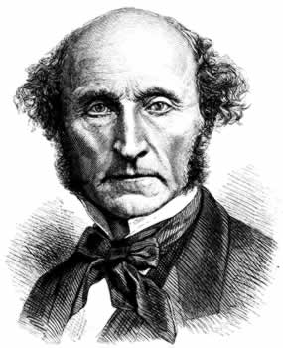**PPE Revision – Ethics**

What was Mill’s big idea?

Utilitarianism – doing “the greatest good for the greatest number”.

The right thing to do is whatever will have the best results for as many people as possible.



What was Kant’s big idea?

The Categorical Imperative – only follow a rule if you want it to be a universal law. If everyone followed your rule, what would the world be like? If it would be a bad world, don’t do it!

What would Kant do in “Transplant”?

Kant wouldn’t kill the healthy person. He might ask himself, “What would the world be like if doctors always killed their patients to save others?” In this world, people with minor injuries would be terrified of going to hospital , which can’t be good. In fact, Kant might point out that in this case, there would be no healthy patients to provide organs!

What would Mill do in “Transplant”?

“Transplant” gives you the choice to kill one healthy person and use their organs to save five healthy people.

Mill would kill the healthy person, because five people being alive is better than only one.

What would Kant do in “Nazis”?

Kant claims he would tell the truth! He thinks that in a world where everyone lies to get good results, no one can trust each other, so lies don’t work. So lying “backfires” on itself.

What would Mill do in “Nazis”?

“Nazis” gives you the choice to lie to an SS officer to save the lives of a Jewish family.

Mill would lie, because the best result would be for the family not to be killed by Nazis.

How could you argue in support of Kant?

* The Categorical Imperative produces lots of sensible rules (e.g. don’t hit someone if they annoy you)
* The CI is fair – you can’t have one rule for you and one rule for everyone else

How could you argue in support of Mill?

* Utilitarianism is fair – everyone’s well-being is counted equally
* It’s also unselfish – you can’t consider yourself more important than others
* It works very well in “normal” situations – like the NHS deciding how to spend money

How could you argue against Kant?

* If you like “bad” worlds, then you’ll be in favour of “bad” rules (maybe you want everyone killing each other!)
* You get a different answer depending on how you describe a rule (e.g. in Nazis – “lie for the greater good” or “lie if it saves five people’s lives”)

How could you argue against Mill?

* Utilitarianism ignores important moral concepts – things like murder, stealing, lying are “just wrong” (e.g. Transplant, Nazis)
* Maybe it’s OK to be selfish (Charity) or to care more about your family than others (Train Tracks)