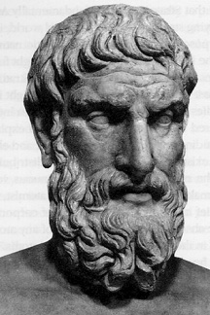
PPE Revision – The Problem of Evil
What is the Problem of Evil?
There is lots of evil and suffering in the world – wars, diseases, natural disasters, etc. If God is omnipotent (can do anything) and benevolent (loving) then he should stop all the evil. He doesn’t, so he must be either not omnipotent or not benevolent (or perhaps he doesn’t exist!)
How could you argue against Hick?
- What amount of learning and growth could possibly justify, for instance, the Holocaust? A good parent would let their child face challenges, but wouldn’t let them run into a road and be killed – it sometimes seems like God doesn’t protect us at all.
- Often, evil doesn’t make people better or stronger – it makes them angry, hateful, or vengeful.

What is Hick’s Soul-making argument?
People need to face challenges and suffering for the development of their souls. A good parent would let their child experience difficulties and disappointment, because it would make them grow into a stronger person. God is the same – evil has to exist, or we wouldn’t have any reason to grow. Suffering can make us stronger, more compassionate, more forgiving, and grow closer to God.
How could you argue against Plantinga?
- What about evil not caused by people? Natural disasters etc. presumably aren’t the result of people making bad choices, so couldn’t God stop them without removing anyone’s free will?
- God has already imposed limits on our free will (we can’t do literally anything we want, like flying) so why doesn’t he limit our free will when we’re planning on doing really horrible things (e.g. stopping murderers)?
What is Plantinga’s Free Will argument?
Wars, murders, and other evils are the result of people making bad choices. God could stop all these evils by taking away our free will and making us do the right thing – but then it wouldn’t really be us doing the right thing, it would be God. If God wants us to be morally good people, he has to let us choose our own actions – and that means sometimes we will choose badly.

